Data Sheet: Activity 7 – Acids and Bases

All Content is Copyright Protected and May NOT Be Posted or Shared Outside Of The Classroom

Name | Course | Date

Activity Data Code

Table I – Raw Reaction Data

Pick four different base solution volumes for your data runs. Note that base volume settings run from 12.00 mL to 16.00 mL (in 0.20 mL increments). Acid Volume at pH = 7.00 can be found on your pH Plots after a data run (see pH Plots tab).

Acid  Solution | Reaction | Acid Volume  at pH = 7.00  (mL) | Base Volume  (mL)
HCl | 1 | 5.44 | 13.6
HCl | 2 | 8.40 | 14.0
HNO₃ | 1 | 7.3 | 14.6
HNO₃ | 2 | 11.25 | 15.0

Observations and Questions

[1] What was your initial (pre-reaction) pH of each base solution? Yes .Does the volume of base solution affect this initial pH? Why?
The volume of the base solution does not affect the pH since concentration is responsible for the change.

[2] Pick one of your reactions above and describe how pH changes as the acid solution is added to the base solution. Why does the pH plot have the shape it does?

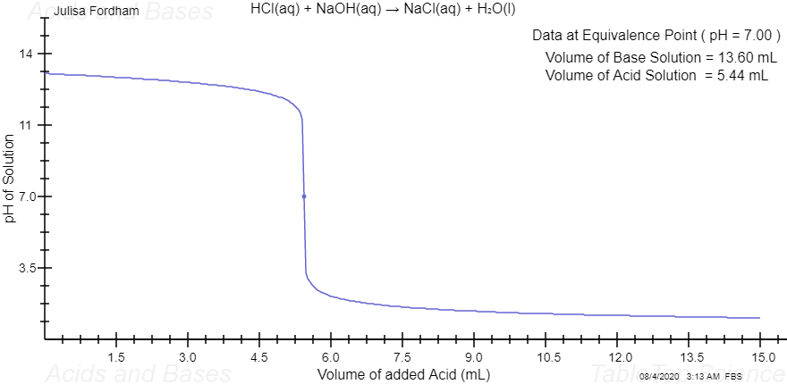
The reaction is between a weak base and a strong acid hence forming the shape of the acid, the strong acid has a greater concentration than the base hence influencing the change in pH

[3] Describe and explain the differences between your different reaction pH plots.

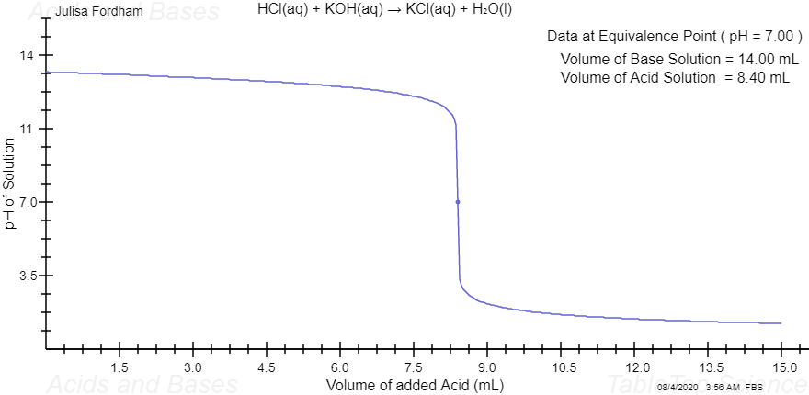
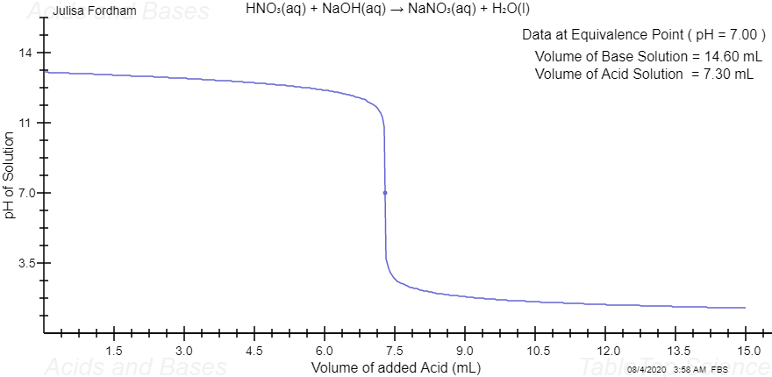
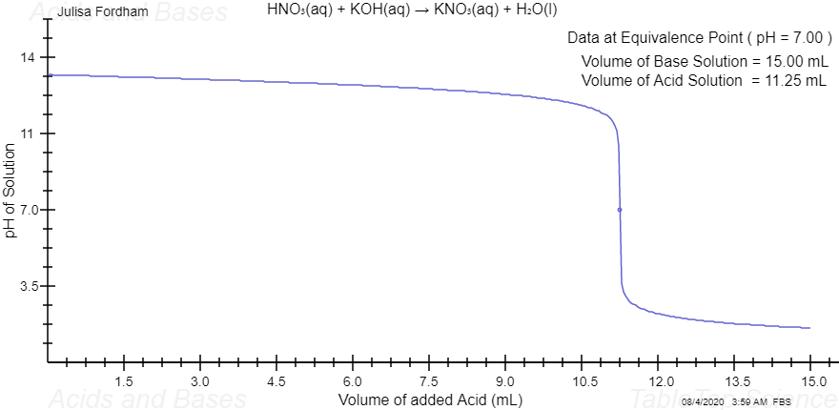

Table II – Moles of Base

Complete the table below using data found under the Activity-Form tab and information found under the Background tab (see the Summary of Needed Formulas section at the very end).

Note: Be very careful with units! Volume must be in liter (L) not milliliter (mL) for moles of base calculation. Example: 1000 mL = 1.000 L, so 15.00 mL = 0.01500 L

Acid  Solution | Reaction | Base  Solution | Base  Concentration (mol / L) | Base  Volume  (L) | Moles of  Base  (mol)
HCl | 1 | NaOH | 0.106 | 0.0136 | 0.0014
HCl | 2 | KOH | 0.159 | 0.014 | 0.0022
HNO₃ | 1 | NaOH | 0.106 | 0.0 | 0.0014
HNO₃ | 2 | KOH | 0.159 | 0.0136 | 0.0022

Sample Calculation: Show your moles of base calculation for HCl (reaction 1).

moles of base= BaseConcentration (mol / L) x Base Volume

=0.106 x 0.0136
=0.0014mol

Table III – Concentration of Acid Solutions

Complete the table below using information found under the Background tab (see the Summary of Needed Formulas section at the very end).

Hint: Remember that the reaction is complete (pH = 7.00) when moles of acid = moles of base.

Note: Be very careful with units! Volume must be in liter (L) not milliliter (mL) for the concentration calculation. Example: 1000 mL = 1.000 L, so 15.00 mL = 0.01500 L

Acid solution | Reaction | Moles of Acid  (mol) | Acid Volume  at pH = 7.00  (L) | Acid  Concentration  (mol / L)
HCl | 1 | 1.4416 | 0.0054 | 265
HCl | 2 | 2.1624 | 0.0082 | 265
HNO₃ | 1 | 1.4416 | 0.0068 | 212
HNO₃ | 2 | 2.1624 | 0.0102 | 212

Sample Calculation: Show your acid solution concentration calculation for HCl (reaction 1).

acid solution concentration= 1.4416 x 0.0054
= 265mol/l

Sample Calculation: Show your acid solution concentration calculation for HNO₃ (reaction 1).

acid solution concentration calculation for HNO₃ =1.4416 x 0.0102
=212mol/l

Table IV – pH of Acid Solutions

Complete the table below using your results from Table III (Acid Concentration in mol/L) and information found under the Background tab (see the Summary of Needed Formulas section at the very end for the pH formula).

Hint: in a strong acid solution the hydronium ion concentration is equal to the acid concentration.

Acid solution | Reaction | Acid Solution pH
HCl | 1 | 2.42
HCl | 2 | 2.42
HNO₃ | 1 | 2.33
HNO₃ | 2 | 2.33

Sample Calculation: Show your acid solution pH calculation for HCl (reaction 1).

pH=-log[H+]
=-log265

Sample Calculation: Show your acid solution pH calculation for HNO₃ (reaction 1).

pH=-log[H+]
=-log212

